**NSCI 20100 Neuroscience Laboratory**

**Contrast Increment Thresholds**

**BSLC 322, January 3 & 5, 2018**

**Goals:** In this lab, you will explore the Weber-Fechner law by measuring your visual contrast increment threshold on different background contrasts. You will collect a substantial psychophysical data set that will allow you to quantitatively assess the relationship between background contrast and contrast increment threshold. You will gain experience with challenges of obtaining high-quality threshold-level behavioral performance, and intuition for the number of trials needed for reliable measurement of binomial variables. This lab will also introduce you to the process of preparing a well-formulated lab report.

**Reading:** There is no required reading for this lab.

**Safety:** There are no lab safety issues related to this study. You will be working only with a desktop computer and its visual display. No personal protective equipment (PPE) is required or recommended.

**Data:** You will collect psychophysical data using five increments at each of four different base contrasts. Working in pairs, each student will serve as a subject for two of the four base contrasts.

**Clean up:** When you have finished, you should quit Matlab, collect any data files from the lab machine and discard your files on the lab machine. You do not need to log out, reboot or shutdown the computer.

**Lab Report:** Lab reports should be prepared following the general instructions found on the course [Canvas site](https://canvas.uchicago.edu/courses/11181/assignments/syllabus). In preparing your report, you should consider the following:

*Introduction:* What is the Weber-Fechner law and how do contrast increments relate to it?

*Methods:* How many stimulus repeats are required to get reliable data? Why was the contrast increment presented only briefly? Why was a two-alternative force choice design selected rather than a yes/no design (in which each trial has a single stimulus that either does or does not increase contrast)?

*Results:* Include a figure showing your data in your report. Are your data consistent between subjects and base contrasts? Can you explain any inconsistencies? What do your data say in terms of the Weber-Fechner law? How will you data be affected if each of the two subjects has a different contrast increment threshold?

*Discussion:* What are your conclusions? What are the limitations of your data? Do your data reveal anything conclusive about the way that sensory neurons use the dynamic range of their rate of firing to contrast?

**Laboratory Procedures**

You will use a Matlab application to collect your data. The necessary software is installed and configured on each of the lab’s computers. Use the following procedures to run the software.

1) Log into the “labuser” account. There is no password for this account: do not enter anything in the password field.

2) Launch Matlab by clicking on the Matlab icon in the dock at the bottom of the display. (Matlab might have a date appended to its name, such as “Matlab_2017a”.)

3) When it launches, Matlab will display a large, multi-paneled window. Launch the Contrast Threshold application by entering “contrastThresholds” (no space) in the Matlab “Command Window” at the bottom of the Matlab multi-panel window.

4) The Contrast Threshold application may take up to 10 s to launch, and it will display warnings in the Matlab “Command Window” and the display window that is created on the screen. The display window will flash a bright red warning when it appears (and whenever it reappears after being hidden during your run of the task). You can safely ignore all these warnings. Once the Contrast Threshold application has finished launching, you will see a display window and a control/data window, which are described below.

5) When you have finished collecting and saving your data, you can terminate the Contrast Threshold application by either 1) closing the Contrast Threshold control panel window using its close button (red button in the upper left corner), 2) closing the Matlab window using its close button, or 3) making Matlab quit using Quit in the File Menu (or the keyboard equivalent, command-Q). In any case, you will be asked whether you are sure you want to quit. All unsaved data will be lost when you quit.

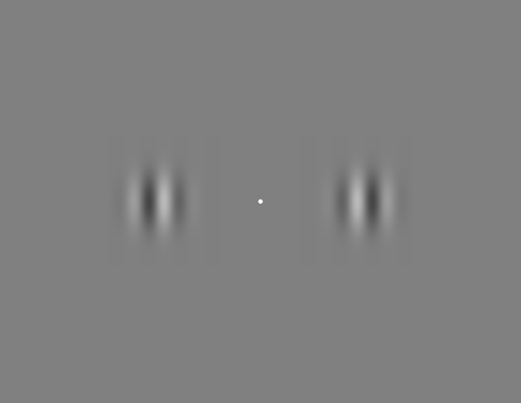

**Running the Contrast Increment Task**

The stimulus display will appear as a dark gray window on the right half of the monitor. The control panel will appear to the left. You should familiarize yourself with the control panel and run some test trials before you start collecting data in earnest. You can clear any test data before you start any real data collection.

There are four different base contrasts: 6.25%, 12.5%, 25% and 50%. When the application runs, it uses only the base contrast selected with the **Base Contrast** menu (see below). Once you press the **Start** button, the task will continue presenting successive trials until you stop it or the requested number of **Stimulus Repeats** has been completed for the selected **Base Contrast**. It is a good idea to set the **Stimulus Repeats** to 5. Once you have collected 5 repeats you can move to a different **Base Contrast** or change the **Stimulus Repeats** 10 and collect additional data.

For each **Base Contrast,** 5 different pre-set contrast increments will be presented: the base contrast will be multiplied by 1.0625, 1.125, 1.25, 1.5 or 2.0. For example, on each trial using a 50% contrast base stimulus, one stimulus will increment to 53.13%, 56.25%, 62.5%, 75% or 100%. These increments have been set to span typical behavior thresholds.

At the start of each trial, a dim white fixation spot will appear, accompanied by a brief tone. You should hold your gaze on the fixation spot throughout each trial, looking away (or blinking) only between trials. Once you have fixated the spot and are ready to start a trial, you signal that you are ready by pressing the down arrow on the keyboard (while maintaining fixation). This will cause the fixation spot to turn bright white and for the two grating stimuli to appear. After the stimuli have been on the screen for the **Base Stimulus Duration** (1 s), one of the two stimuli, selected at random, will increase its contrast. The change will last for only the **Test Stimulus Duration** (0.25 s), after which both grating patterns will disappear and the fixation point will turn black. You must indicate which of the two gratings increased contrast by pressing either the left or right arrow on the keyboard. There is no time limit for your response. Once you respond, you will hear a tone indicating whether your selection was correct (high tone) or incorrect (low tone). The task will then pause for the **Inter-trial Duration**, after which the next trial will start.

When working on the task, you should not let yourself get distracted by the updating data in the control panel. If you can’t remain focused, you can move the panel so the data table and plot are off the bottom of the screen.

Breaks: You can take a break at any time by pausing the task. It is also fine to leave the task waiting with the dim fixation spot on the screen. You can stop part way through completing one base contrast to take a break while your partner works on another base contrast. Both subjects should contribute data to each base contrast.

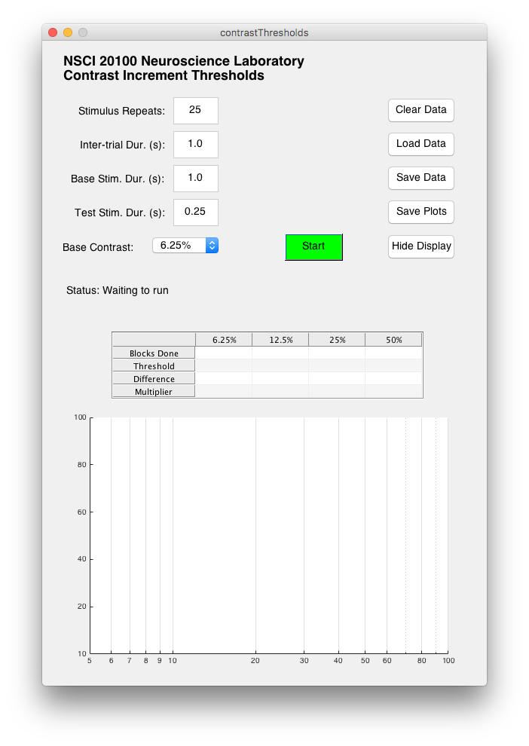**Controlling the Contrast Increment Task**

The following controls and displays are available on the Control Panel.

**Stimulus Repeats:** The number of times each increment will be repeated before the task stops. When you reach the limit, you can always increase this number to collect additional data.

**Inter-trial Dur. (s):** The pause between on trial and the start of the next. You may adjust this, but you should leave enough of a pause so the subject is not rushed.

**Base Stim. Dur. (s):** The duration of the adapting stimulus. Leave this set to 1.0 for all measurements.

**Test Stim. Dur. (s):** The duration of the test stimulus. Leave this set to 0.25 for all measurements.

**Base Contrast:** Use this menu to select which of the four base contrasts you will test.

**Clear Data:** Delete the data for the current base contrast (only). If you want to clear a different base contrast, you must select that base contrast using the Base Contrast pop-up menu first.

**Load Data:** Load previously saved data from a Matlab -mat file. *Caution:* Loading data will overwrite existing data. You should save any important current data before Loading Data.

**Save Data:** Save the current data set as a Matlab -mat file. Data saved in this way can be reloaded later. This can be useful if you must quit and relaunch the program.

**Save Plots:** Save the current contents of the control dialog as a PDF.

**Hide Display (Show Display):** Toggle whether the stimulus window is displayed. This is useful if you need to get access to the desktop. Controls are disabled while the display is hidden.

**Start (Stop):** Toggle whether the task is running. You can also use the space bar when the control window is front-most.

**Results Table:** The first row shows the number of blocks (of five contrast increments) completed for each base contrast. Once a few blocks have been, the table will also display the threshold contrast, the difference between the threshold contrast and the base contrast, and the ratio of the threshold contrast and the base contrast. These values are based on the fitted function shown in the Performance Plot.

**Performance Plot:** The performance plot shows the percent correct for each increment. Increments on different base contrasts are plotted in different colors. Colored solid vertical lines mark the four different base contrasts. Average percent correct are plotted with circles, and bars mark the 95% confidence intervals. Once a few blocks of data have been collected, a fitted function will be plotted. The fit is based on the five increments and an equally-weighted point at 50% correct at the base contrast. The function is:

$$0.5+\frac{0.5}{e^{(-β*\left(c-∝\right)}}$$

where *c* is contrast,  is the contrast increment threshold (75% correct), and  determines the steepness of the function.